Landscapes of Imagination
2015 Biennial Reggio Emilia Australia Information Exchange Conference
Melbourne July 2 – 5th

A Reflection by Jenny Dudgeon

I was very fortunate to attend the recent Landscapes of Imagination
2015 Biennial Reggio Emilia Australia Information Exchange Conference in Melbourne thanks to the Network of Education Associations of Tasmania (NEAT) scholarship which supported the funding of my registration. I attended representing Early Childhood Educators of Tasmania Inc South, a member group of NEAT.

At the conference I was one of only nine Tasmanian early childhood educators in attendance.
The sold out, stand out conference hosted 1300 early childhood educators from across Australia and New Zealand! It is encouraging that NEAT through this scholarship program offers the opportunity for Tasmanian educators to access high quality national professional development and the chance to establish national professional networks as often conference registration, travel time and on costs are prohibitive for Tasmanian educators.
At the conference I was able to meet with many national early year’s education providers (who are not operational in Tasmania).One such meeting facilitated a shared partnership with Kindergarten Union (KU) and ECET to bring internationally acclaimed early years educator Ann Pelo to Tasmania in 2016.
Through the Reggio workshop showcasing Australian Reggio Emilia practice Landscaping for Imagination: Re-conceptualising Environments presented by South Australian, Paul Johnson from Galilee School, ECET South and Catholic Education have partnered to host a series of workshops with Paul in May 2016 to promote, inspire and provocate Tasmanian educators to reconceptualise their outdoor environments and re-consider how outdoor environments and outdoor play engage children in purposeful learning. The children at Galilee shape their experience rather than the experience shaping the child and the landscapes created document their ideas. Questions arose about the risk benefit analysis of outdoor play. Paul believes strongly that all children are risk managers – yes their kids climb trees!

The conference program had outstanding Reggio Emilia Italian based researchers/ educators, Atelier, Francesca Manfredi and Pedagogista and Reggio Emilia International board member, Claudia Giudici, who were vibrant, engaging key note speakers.

The title of the conference was Landscapes of Imagination a conference for enlivening our own imagination and exploring more deeply the curiosity and imagination of children as they connect and interconnect within and between the arts, sciences, reality, fantasy, identify and towards transformation.
Landscapes of Imagination was inspired by the innovative Reggio Emilia Approach which is an educational philosophy focused on preschool and primary education.
It was developed by Italian teacher Loris Malaguzzi. Following the WWII, people believed that children were in need of a new way of learning: the assumption was that people form their own personality during early years of development and, moreover, that children are endowed with "a hundred languages". The aim of this approach is teaching how to make them (the 100 languages) useful in everyday life. The program is based on the principles of respect, responsibility, and community through exploration and discovery in a supportive and enriching environment based on the interests of the child through a self-guided curriculum that develops education projects based in and around Reggio Emilia. - using the city and its environment at the 3rd teacher. I believe strongly in the value of the environment as the 3rd teacher.
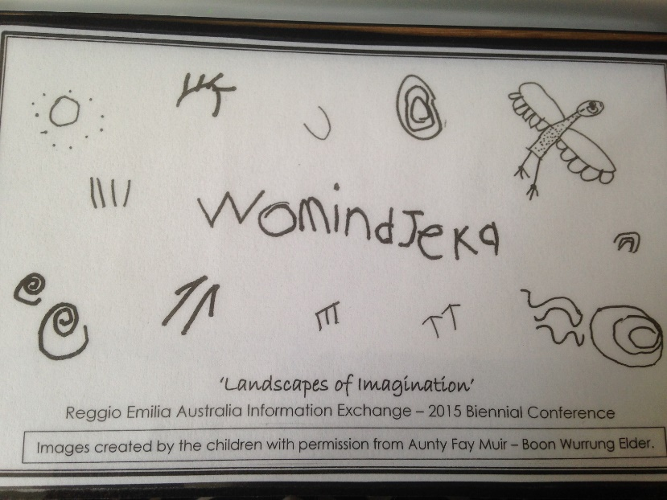
The focus of the conference was to challenge old paradigms of thinking and take courage to explore and imagine a new world for all children. Educators through considered questioning, provocations and environmental choices set the scene for valuing highly children’s imaginations and wonderings, encouraging many viewpoints and (entry points) for and of learning.
The Early Years Learning Framework (The EYLF) is the innovative guiding document for all early years educators and there are strong synergies between the EYLF and Reggio approach as it recognizes the complex nature of young children’s learning and provides principles and practices to guide educators working with children birth to 5 years of age and has at its centre children’s learning. The EYLF has five learning outcomes
- Children have a strong sense of identity
- Children are connected with and contribute to their world
- Children have a strong sense of wellbeing
- Children are confident and involved learners
- Children are effective communicators
Educators use the outcomes to observe children and plan for their ongoing development. The Reggio Conference gave many practical applications of effective ways to observe and document children’s learning. The guest Reggio educators also provided a number of significant case studies that promoted discussion and reflection amongst the Australian educators about the interplay of the EYLF and Reggio approach. When using the EYLF educators acknowledge that children learn in a variety of ways and provide quality learning environments that are inclusive of all children which mirrors the Reggio tenets.
Imagination can be a catalyst for social change and has a significant place in education.
Einstein considered,
Imagination is more important than knowledge. For knowledge is limited to all we now know and understand, while imagination embraces the entire world, and all there ever will be to know and understand.”
http://www.goodreads.com/quotes/556030-imagination-is-more-important-than-knowledge-for-knowledge-is-limited
What is the place of imagination in education?
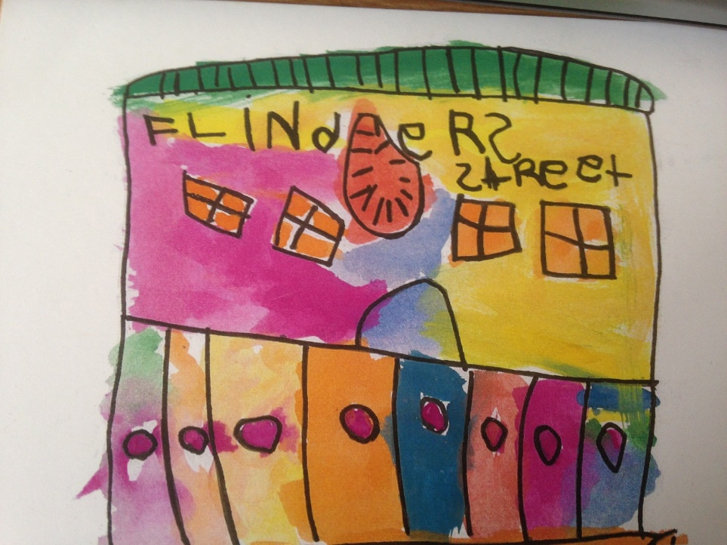
The word imagination does not appear in the government's list of goals, nor does it turn up on lists of behavioural objectives or educational outcomes. There is no imagination curriculum or pedagogy of the imagination in our schools. Yet if, as the poet Wallace Stevens wrote, "the imagination is the power of the mind over the possibilities of things" then to neglect the imagination is also to impoverish children's worlds and to narrow their hopes. The possibilities of things - the counterfactual world of supposing and imaginings make it possible for children to stretch themselves beyond their everyday realities and confront experience with the question, What if?
Manfredi and Giudici also focussed on the role of the digital environment – stressing that these were tools for research and a digital environment offers a system of possibilities.
Documentation (observation and recording of children’s thinking and conversations) is pivotal to the Reggio approach as it forms up the concept of the child, their learning interests and needs and how best next day’s program can address these.
At the Loris Malaguzzi International Centre in Reggio Emilia the children used web cams, computers, data projectors, overhead projectors, mirrors and digital cameras to explore the geography of their environment to investigate the real and virtual environments and consider their hypothesis, Can we see infinity? A big concept for 3 – 6 years old to grapple with but their understandings were quite reasoned.

Another inventive aspect of the conference was the series of RED talks Reggio EDucation with key Australian educators sharing their stories, aha moments, research projects and provocations using the Reggio approach.

The key message for early years educators from the conference was be mindful of the 100 Languages of Children – consider these possibilities, Listen to the whole child, - be with the child, document, re-listen, reflect, connect with the environment, feed their ecological sensibilities, co construct provocations and be ready for the unexpected!

I would like to thank NEAT for their support enabling my participation in the biennial national Reggio Conference. The opportunity to learn more about the internationally acclaimed Reggio approach to early year’s education will benefit my teaching and programs offered at the Sustainability Learning Centre.
Attending the conference also facilitated many valuable opportunities to network with mainland educators which has resulted in diarising new professional learning opportunities for members of ECET Inc, fostered a closer relationship with REAIE and a partnership with Reggio Tasmania.

ECET meetings have provided opportunities to promote and share Reggio’s innovative approaches. Through discussions with colleague educators we have begun to evaluate and disseminate current Reggio practises and research and share professional learning opportunities.

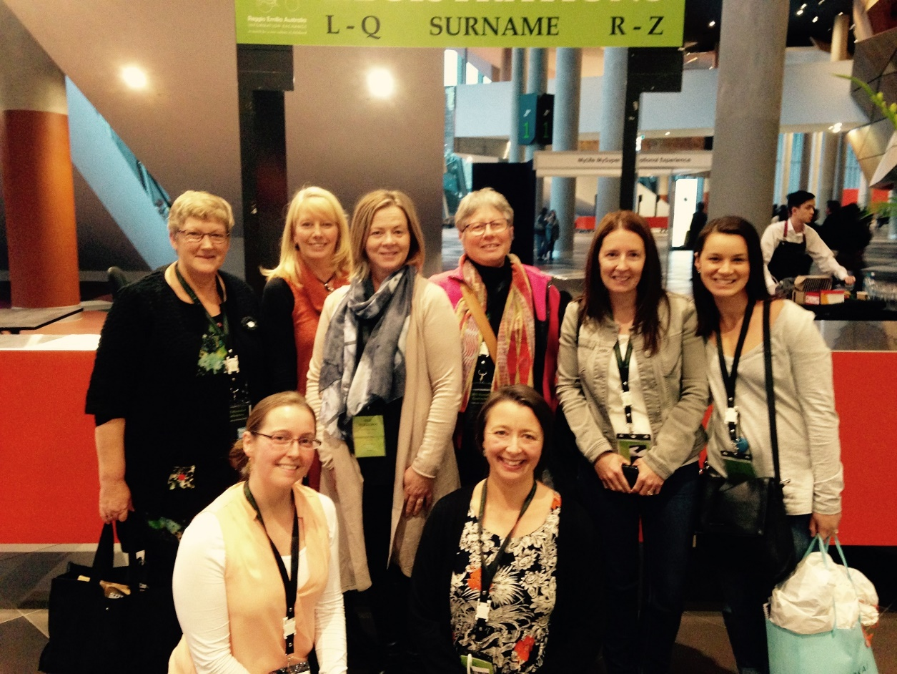

The ECET South members attending the 2015 Reggio Conference.

Thank you,

Jenny Dudgeon

Manager Sustainability Programs
Sustainability Learning Centre
Hobart College
Mt Nelson 7007

